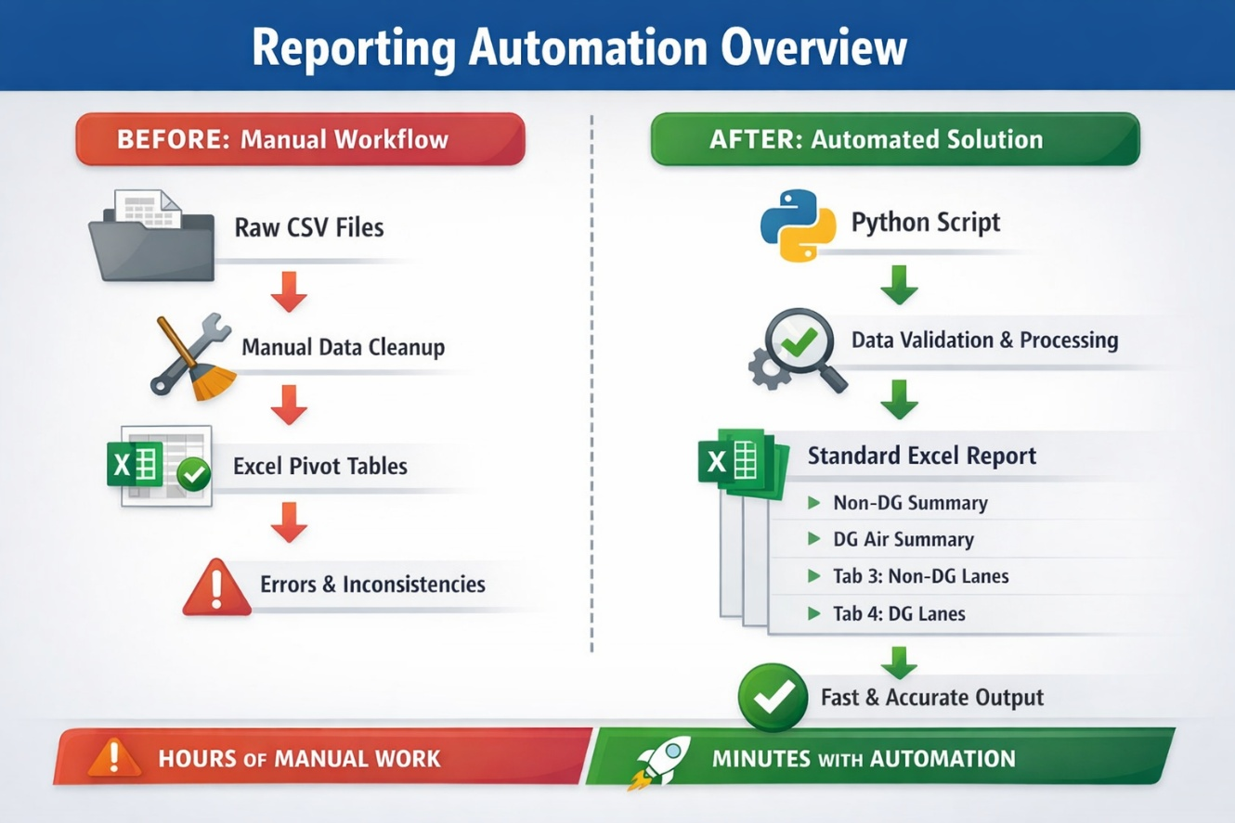
Executive Summary (Non-Technical)
Automated Python solution that converts raw logistics CSV exports into a standardized, multi-sheet Excel report in minutes.
The process replaces manual Excel manipulation, reduces operational risk, and guarantees consistent KPI calculations for DG and Non-DG shipments across all reporting periods.

Who Is This For
- Operations & Logistics Managers
- Supply Chain Analysts
- Finance & Planning Teams
- Business stakeholders who need reliable Excel-based reports

Problem Statement
The logistics team received periodic CSV exports containing outbound shipment data that required extensive manual processing.
This included cleaning numeric fields, separating DG and Non-DG shipments, building pivot tables, and manually enforcing report layouts.
The process was time-consuming, error-prone, and inconsistent across reporting cycles.

Solution Overview
A Python-based reporting automation was developed to ingest raw CSV data, apply business rules, and generate a ready-to-share Excel file with predefined structure.
The solution validates input data, normalizes values, calculates KPIs, and outputs standardized summaries without exposing sensitive internal naming.

Visual Flow (Before / After)
Before
- Raw CSV exports
- Manual data cleanup
- Excel pivots and formulas
- High risk of calculation and layout errors
After
- One-run Python script
- Automated validation and aggregation
- Fixed multi-sheet Excel output
- Consistent KPIs and structure

Business Rules & Logic
- Required columns are validated before processing
- Numeric fields are safely converted and normalized
- Country codes are mapped to neutral subsidiary identifiers
- Ship methods are standardized (Air, Ocean, Truck, Vessel)
- Shipments are split into:
  - Non-DG (DG = NO): Air and Ocean
  - DG (DG = YES): Air only
- KPIs calculated:
  - Lines = Delivery Order count
  - Quantity = sum of delivered units
  - Weight = total gross weight
  - CBM = total shipment volume
- Missing lanes are included with zero values to preserve layout

Output & Deliverables
A single Excel file containing:
- Non-DG Subsidiary Summary
- DG Air Subsidiary Summary
- Tab 3: Template-driven Non-DG lane report
- Tab 4: Template-driven DG lane report
All sheets follow a fixed, audit-ready structure.

Business Value
- Eliminates repetitive manual Excel work
- Ensures consistent KPI definitions
- Reduces operational and reporting risk
- Improves trust in reported logistics metrics

Results & Impact
- Reporting time reduced from hours to minutes
- Manual processing steps reduced by over 90%
- Zero dependency on manual formulas or pivots
- Fully repeatable process for future reporting cycles

Tech Stack
- Python
- pandas
- XlsxWriter
- pathlib

My Role
- Requirements analysis
- Data cleansing and normalization
- Business rule implementation
- Python development
- Report standardization and validation

